
MATHEMATICS DEPARTMENT

Year 12 Methods - Test Number 4 - 2016
Integration and Logarithms
Resource Rich (but NO notes)

Name: _______________________________________ Teacher: __________________

Marks: 55
Time Allowed: 45 minutes
Instructions: You are allowed to use Calculators but NO notes.
You have been supplied with a formula sheet.
__________________________________________________________________________________________

1 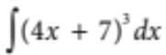 =
A 16 (4x  7)4  c
B 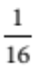(4x  7)4  c
C (4x  7)4  c
D (4x  7)4  c
E 4(4x  7)4  c
[1 mark]

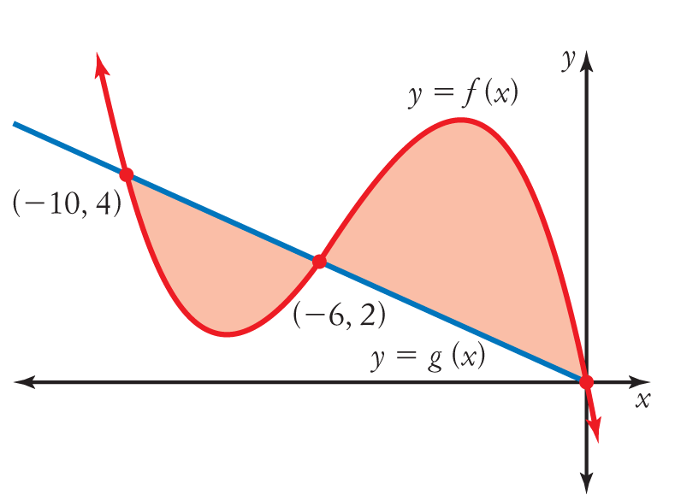
2 The shaded area at right can be written as:
A 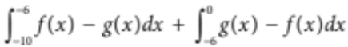
B 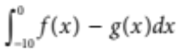
C 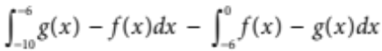
D 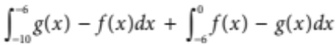
E 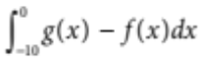
[1 mark]

3 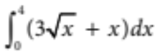
A 24
B 16
C 32
D 20
E 0
[1 mark]
4 If the derivative of 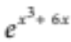 is 3(x2  2) 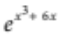, then the antiderivative of (x2  2) 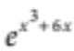is:
A 9(x2  2) 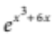
B (x2  2)
C 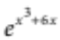  c
D (x2  2)
E 3(x2  2) 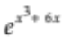
[1 mark]
5 Water flows into a container at the rate R´(t) = 10e0.2t (L/min) where t is in minutes. What is the total number of litres (to the nearest litre) that flowed into the container in the first 5 minutes?
A 50
B 86
C 120
D 136
E 75
[1 mark]
6 Evaluate the logarithm log₇ 126 using the change of base formula. Round to 3 decimal places.
A 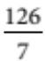
B 2.485
C 0.402
D 2.890
E –2.890

[1 mark]
7 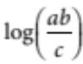 is equal to:
A [log (a) × log (b)] ÷ log (c)
B log (a) + log (b) − log (c)
C ab log 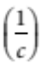
D log_{e}(ab)
E None of these

[1 mark]
8 If f(x) = log_{e}(2x), then f ′(1) equals:
A 1
B 2
C
D log_{e}(2)
E 2log_{e}(2)
[1 mark]
9 If log₁₀ (7) = a, then log₁₀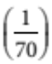
A –(1 + a)
B 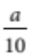
C (1 + a) ⁻¹
D 1 + a
E 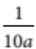
[1 mark]
10 If log_{x} (y)= 100 and log₂ (x)= 10, then the value of y is
A 2¹
B 2¹⁰
C 2¹⁰⁰
D 2¹⁰⁰⁰
E 2¹⁰ ⁰⁰⁰

[1 mark]
11 Find each indefinite integral.
a 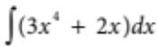

b 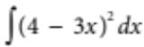

c 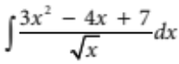

[4 marks]
12 Find y in terms of x if 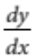 = 14x  4 and y = 8 when x = 1.

[3 marks]
13 Find given y =log_{e}(2x + 1).

[2 marks]

13 Sketch the graph of the function f(x) = –ln(2x). Determine the range and the domain of the function.

[4 marks]
14 Anti-differentiate 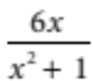.

[2 marks]
15 Find the EXACT value of 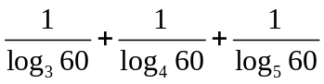

[4 marks]
16 It can be shown that the acceleration of a particle is given by the differential equation
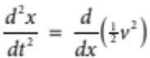, where v is the velocity.
The acceleration of a particle is given by 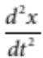 = 6x2  4x  3, where x is its displacement. Find the exact velocity when the particle is 2 cm from the origin if initially the particle is at the origin and has a velocity of 3 cm/s.

[4 marks]
17 The annual growth rate for an investment that is growing continuously is given by 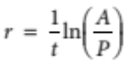 where P is the principal and A is the amount after t years. An investment of $10 000 in Dell Computer stock in 2009 grew to $31 800 in 2012.
a Assuming the investment grew continuously, what was the annual growth rate (to 4 decimal places)?

b If Dell continues to grow at the same rate, what will the $10 000 investment be worth in 2016?

c Assuming the investment grew continuously at the same rate, how long will it take for the $10 000 investment to grow to $500 000?

[8 marks]

18 The magnitude, M, of an earthquake is measured using the Richter scale M = 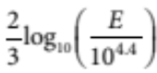 where M is the magnitude and E is the seismic energy released by the earthquake (in joules). On 25 September 2003, an earthquake measuring 7.6 on the Richter scale shook Hokkaido, Japan. How much energy (joules) did the earthquake release?

[3 marks]

19 A farmer has one cow with a contagious disease in a herd of 1000. If the cow is left untreated, the time in t days for n of the cows to become infected is modelled by: 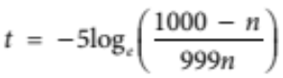
a Find the number of days (to 1 decimal place) that it takes for the disease to spread to:
i 100 cows

ii 200 cows

iii 998 cows

iv 999 cows.

b Find how many cows will be infected after 35 days.

c Sketch this function for 0 < n ≤1000.

d Using this model, describe the rate at which this contagious disease spreads over time.

[11 marks]

[Total marks: 56]

1 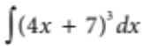= 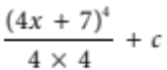
MATHEMATICS DEPARTMENT

Year 12 Methods - Test Number 4 - 2016
Integration and Logarithms
Resource Rich - SOLUTIONS
= (4x  7)4
   B [1 mark]
2 Area between x = 10 and x = 6 is 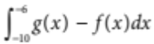
Area between x = 6 and x = 0 is 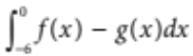
Total area = 
 D [1 mark]
3 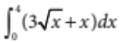= 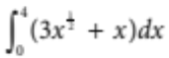
= 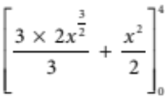
= 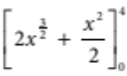
= 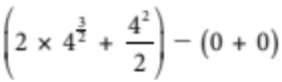
= 2 × 23  8
= 24
 A [1 mark]
4 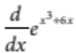= 3(x2  2) 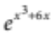
So 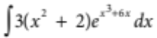 = 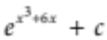
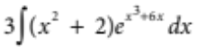=
So 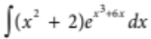 = 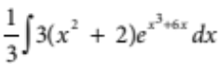
= 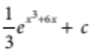
 C [1 mark]
5 Total change = 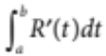
= 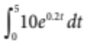
= 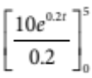
= 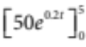
= 50e1  50e0
= 85.914…
 B [1 mark]
6 B [1 mark]
7 B [1 mark]
8 A [1 mark]
9 A [1 mark]
10 D [1 mark]
11 a = 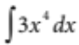 + 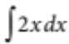
= 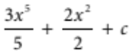
= 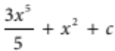 [1 mark]
b = 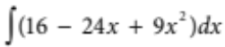
= 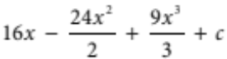
= 16x  12x2  3x3  c =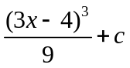 [1 mark]
c 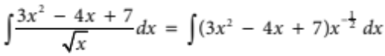
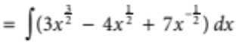
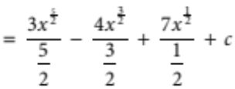
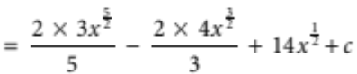
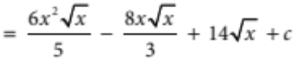 [2 marks]

12 = 14x  4
y = 7x2  4x  c [1 mark]
y = 8 when x = 1, so 8 = 7 × (1)2  4 × 1  c
8 = 11  c
c = 3 [1 mark]
y = 7x2  4x  3 [1 mark]

13 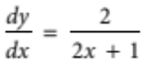 [2 marks]
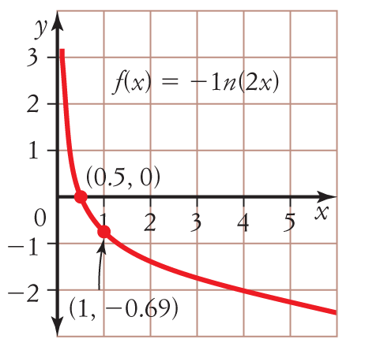
13?

[2]

[4 marks]
Domain (x : x > 0}, Range R [2]
14 Since 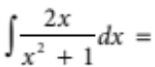 log_{e}(x²+1) + c
then 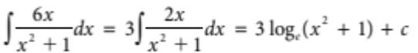 [2 marks]
15 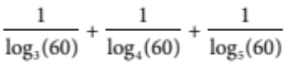
= 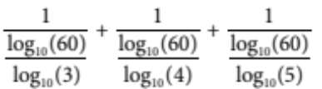 [1 mark]
= 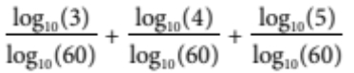 [1 mark]
= 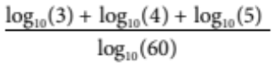
= 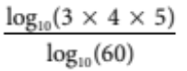
= 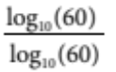 [1 mark]
= 1 [1 mark]

16 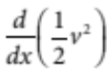= 6x2  4x  3
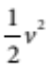= 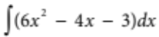 [1 mark]
= 2x3  2x2  3x  c
When x = 0, v = 3
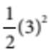 = 2(0)3  2(0)2  3(0)  c
c =
= 2x3  2x2  3x 
v2 = 4x3  4x2  6x + 9
v = 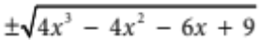 [1 mark]
The condition v = 3 when x = 0 is satisfied by:
v = 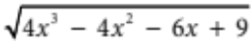 [1 mark]
When x = 2,
v = 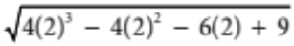
= 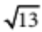
When x = 2, v = [1 mark]

17 a 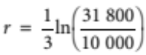
≈ 0.3856 [2 marks]
Therefore, the annual growth rate is 0.3856 or 38.56%.
b 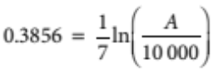
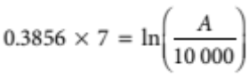
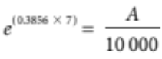
10 000e^{(0.3856 × 7)} = A
A = $148 678.33 [3 marks]
c 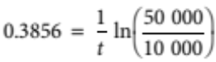
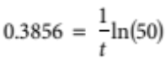
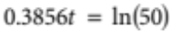
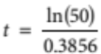
t = 10.1453 [3 marks]
Therefore, it will take 10.1453 years after the year 2009 for the $10 000 investment to grow to $500 000.
18
[1 mark]
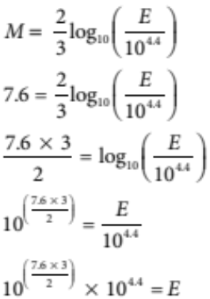

[1 mark]

E = 6.3 × 10¹⁵ joules [1 mark]

19 a i n = 100, t = 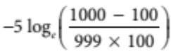
t = 23.5 days
ii n = 200, t = 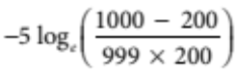
t = 27.6 days
iii n = 998, t = 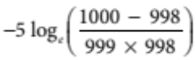
t = 65.6 days
iv n = 999, t = 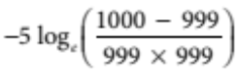
t = 69.1 days [4 marks]
b t = 35, 35 = 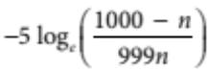 [1 mark]
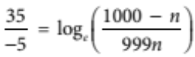
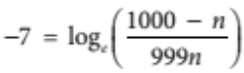
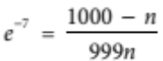
e^{–7} × 999n = 1000 – n
999e^{–7}n + n = 1000
n(999e^{–7} + 1) = 1000 [1 mark]
n = 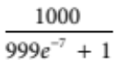 [1 mark]
n = 523.3 [1 mark]
After 35 days there are 523 cows infected. The 0.3 means that cow number 524 has also contracted the disease partially. Therefore, there will be 524 cows infected after 35 days.

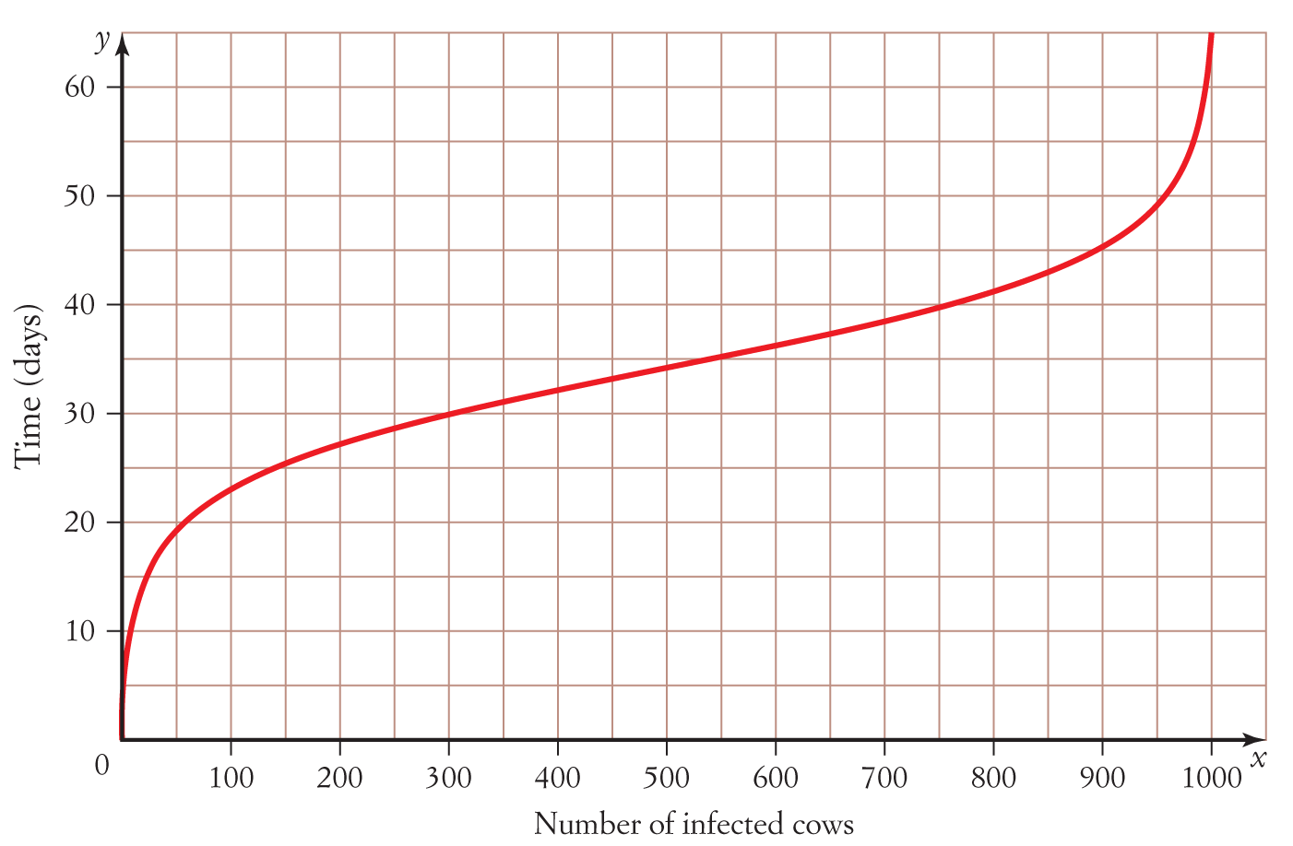
c

[2 marks]
d This contagious disease can spread very rapidly at first and then very slowly as nearly all of the population has become infected. It is called a logistic growth model.
[1 mark]

